Expounding on the Play

Student Name
Institutional Affiliation
Professor’s Name
Course Name
Date

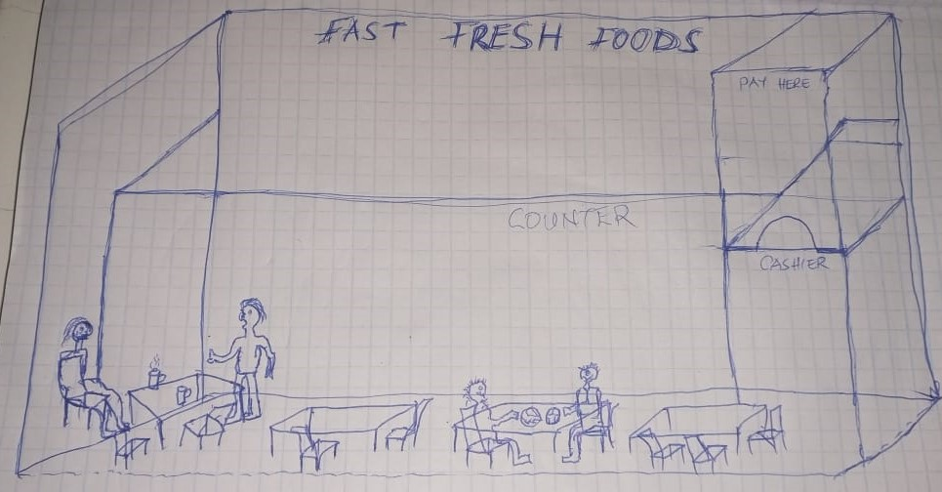
Drawing of a set from above
In this play, a platform kind of stage is being used. The audience is sited in rows facing the scene, which is on a raised floor. The platform stage is set in a restaurant where Anderson is sited at a corner waiting for John. The platform stage, referred to as an end, or open stage, is mostly set up like a raised rectangular platform at the end of a room. The idea is to bring whichever setting in place within that space and act out the perfect location of that stage (Walmsley, 2019). Like in the drawing above, it is clear that the platform stage will work best to give the expected outcome of the play.
The blueprint for the stage is indicated in the sketch. It is a two-dimensional piece that illustrates how the setting of the performance should be designed. A blueprint can either be through a hand sketch or software for creating art pieces. For these plays, the blueprint is very simple and precise. We are only interested in the Restaurant as a meeting point for Anderson and John as they talk. Therefore, we reduced the complexities of house plan blueprints which are quite detailed and complex (Foster & Marcus Jenkins, 2017). The blueprint contains a setup of a restaurant and very few people in it but with the necessary facility to make it a restaurant.
The set pieces used in the play are a sunny day, the right corner of a restaurant, and a wristwatch. The sunny day is symbolic of a bright day, full of expectation and life. We expect that Anderson is in the Restaurant for breakfast and waiting on a client to discuss important business matters as the beautiful day unveils. The right corner is an indication of privacy-seeking; Anderson chose that corner spot so that he could be isolated from the rest of the Restaurant (Welch, 2017). This indicates that Anderson is expecting someone with whom they will have a serious discussion that requires minimal destruction. The wristwatch is a time-bound affair; Anderson is either getting late for something or is disturbed by the time range he has waited. John is late for almost an hour from their initial statements. Therefore, the wristwatch is a set piece for time and patience for a meeting between John and Anderson. The Restaurant is also a fine set piece where people meet for private and public encounters outside their normal routine at work.

References
Foster, E. M., & Marcus Jenkins, J. V. (2017). Does participation in music and performing arts influence child development?. American Educational Research Journal, 54(3), 399-443.
Walmsley, B. (2019). Audience engagement in the performing arts: A critical analysis. Springer Nature.
Welch, E. R. (2017). A Theater of Diplomacy: International Relations and the Performing Arts in Early Modern France. University of Pennsylvania Press.

